 | 12.1.12 Editors - Geometry Nodes Editor - Header - Add Menu - Input - Group
Table of content
Add menu - Input - Group 1
Group Input 1

Add menu - Input - Group
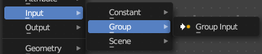
Here you find input nodes.

Group Input
Adds a Group Input node. This node is usually already part of a new created group.
See also chapter Add Menu - Group

